**The Wacky Get Together**

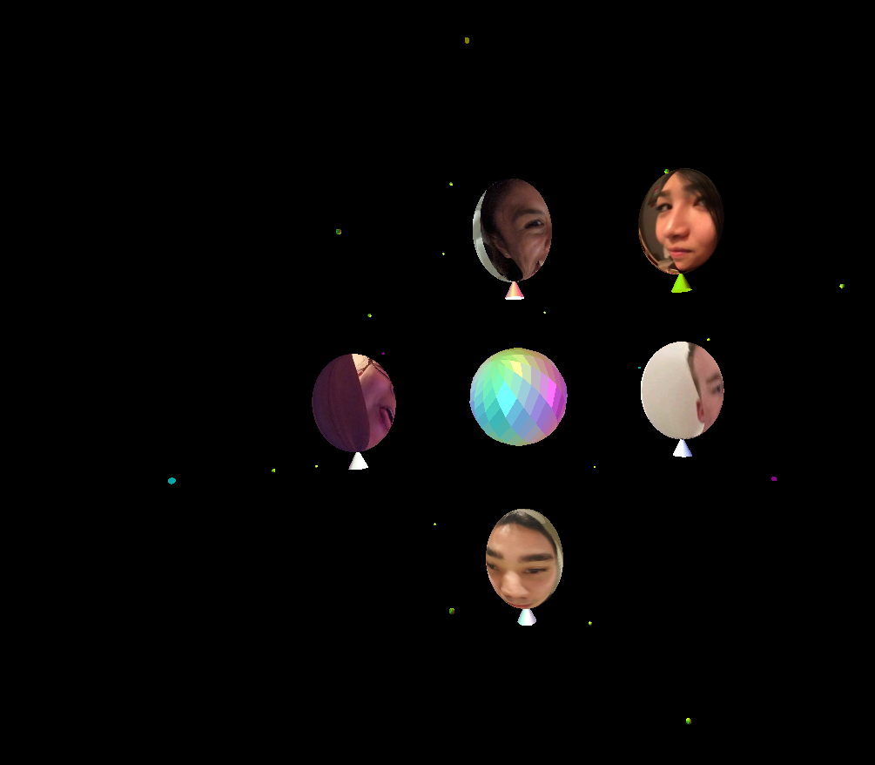

Rhea Mae V. Edwards

edwardrh@oregonstate.edu

**PROPOSAL**

The overall idea of my proposed final project is to create a scene with five balloons textured with pictures of people I know, along with additional animation and lighting within the scene. Being inspired and how I enjoyed the texture assignment with being able to play around with pictures of my friends’ faces, I wanted to be able to base my final project off that assignment and taking it up a notch.

First, I will create the structure of the balloons. To make a balloon, I will create a sphere by the given sphere code from Project #3, and then scale the sphere in order to create a more balloon-structured shape. Then at the base of each transformed sphere, I will take three triangles, placing them together to form a pyramid at the base of the balloon in order to create a more balloon-like look to the 3D objects. Also, these pyramids will represent the color of the balloon after the texture has been placed on the transformed sphere, and the colors chosen will also be the favorite color(s) of the person’s face of the balloon! Kind of like hidden messages throughout the scene.

Next, I will use the BmpToTexture(), glGenTextures(), glBindTexture(), and other corresponding functions to place the different textures of my friends’ faces onto the created 3D objects in a single scene at once. Then to make the faces a little bit livelier, I planned to distort the textures and then animating them. In addition, I plan on moving the balloons around the scene, as if they were mingling and socializing with one another.

Then, to really make it seem more like a celebration, being close to the end of the term, I also would like to add a representation of a disco ball located at the middle/center of the scene. Simply being just a flat-shaded sphere, colored silver. In addition, place point lights throughout the scene giving off different colors of light. And at each of the light sources, place minor corresponding colored sphere. Possibly some of the light sources can also move around within the scene, adding more life to the environment of the objects.

I also plan to include a key that toggles on and off the light sources and possibly change their colors just for fun, and also a key that will turn the textures on and off of the balloons, so that the viewer will have the option to either see the balloons with people’s faces on them or just the solid colored objects and their assigned colors. I will also give the option for the viewer to freeze and unfreeze the movement of the objects throughout the scene, and the option to add or remove the distortion of the textures of the balloons.

Overall, my final project will include five animated textured balloons. The textures on the balloons will consist of .bmp files of my close friends’ faces. I will also distort and animate the textures (pictures of their faces) in order to give off a more party/silly effect to the scene; upholding the current name of my final project “The Wacky Get Together”. These textured 3D objects that represent the shape of a balloon, will also move around the scene, each balloon having its own designated path along the screen, providing additional movement for its viewer to look at and enjoy. To also provide a more celebratory effect, I plan on including a disco ball at the center, surrounded by different colored light point sources at various locations lighting up their surrounding objects. Lastly, providing the viewer with a number of options to alter the scene.

I am very excited to work on and complete this potential project idea, because what is more fun than getting to play with your friends’ faces in a fun and unique way!

(With their permission of course ☺)

**REPORT**

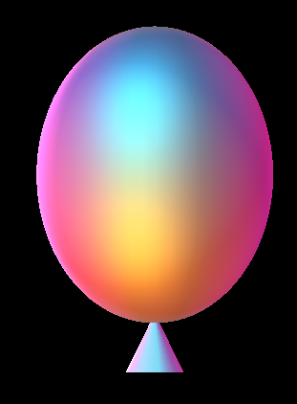

For my project, I decided on a celebratory scene with the fun of animating my friends’ faces through textures and displaying the colorful effects OpenGL lighting has to offer.

To begin my project, I started off using the sphere that was provide in Project #3, knowing that I plan of applying textures to this object of a balloon later. I took the sphere created by the given MjbSphere() function that I then scaled into a more oval 3D object to make it look like a body of a balloon. Then, I added a cone generated by glut solids to add to the base of the sphere to make it look like the part of a balloon where you blow air into it, which required some additional transformations of a translation and a rotation to apply it where I wanted it onto the sphere.

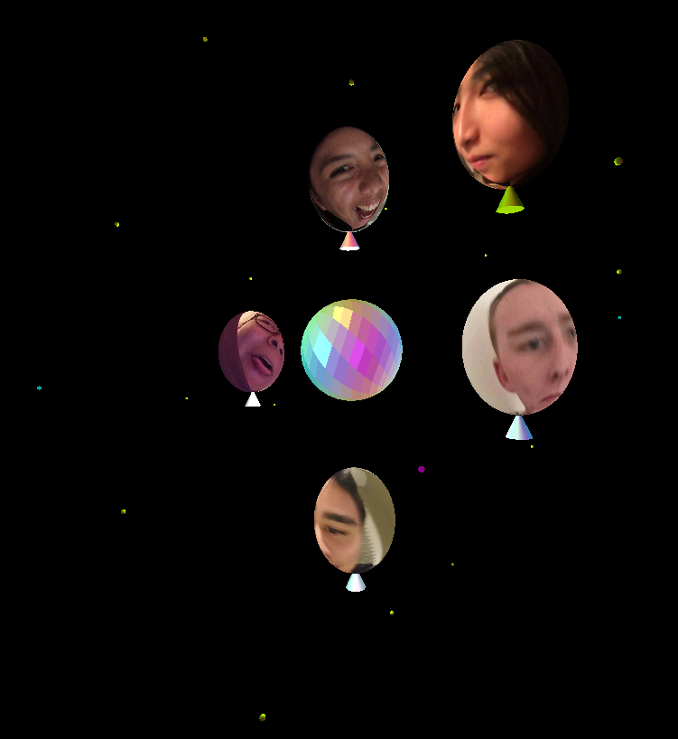I then took this pair of objects that I created in a display list and duplicated the list four more times, in order to make five separate balloons in total. With each balloon, I translated them across the scene. And then changed each balloon’s color to each of my friends’ favorite colors, so when the textures are not applied to these objects, these colors are revealed, which I generated with the ColorPicker.exe, being unique to each person’s face throughout the scene. Lastly to complete each balloon, I applied my friends’ faces to each of the balloons, corresponding to their favorite color applied. I used the BmpToTexture() function from Project #3 in order to complete this task. In addition, I also provided the option for the viewer to remove/apply the textures throughout the scene by a menu option.

Next, I created the disco ball in the middle of the scene. Simply I generated a glut solid sphere that is really shiny, flat shaded, and colored silver. And then sliced it in a way that I thought was visually appealing overall.

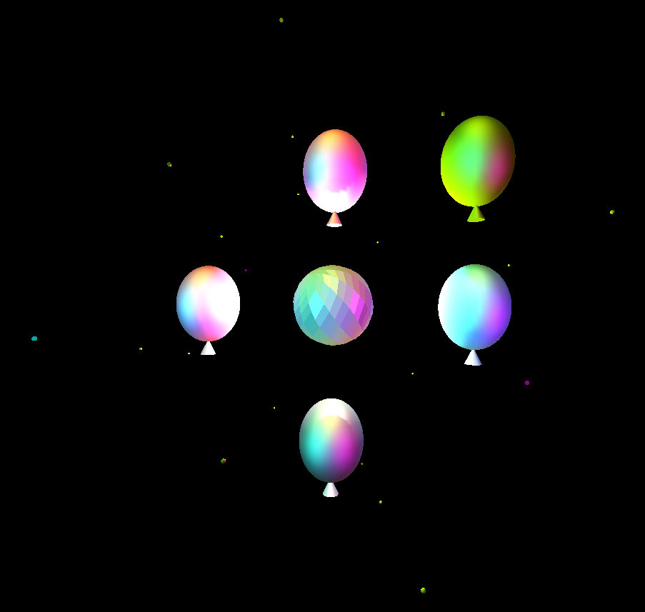Then, I created point light sources to add some lighting to the scene, with the help of the given setlight.cpp file provided in Project #4. Realizing that the initial code that was provide for the class, only allowed us to use up to eight light sources (and also unknowingly how to add more), I created six point colored light sources consisting of three different colors, two of each color, placed symmetrically throughout the scene. The three colors being a type of purple, yellow, and blue, created by using the ColorPicker.exe. And then I added two point white light sources on opposite points within the disco ball, adding an additional bright light to the disco ball in the middle.

Each light source has a tiny corresponding colored sphere at its location to help indicate each light source, and also to add a little more life to the scene representing a celebratory environment. In addition, I added fourteen simply shiny, silver, tiny spheres throughout the scene for the reason of additional life. Also being silver and shiny, each sphere is also able to reflect the lights surrounding it, as an additional effect to the scene.

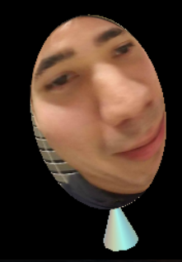Lastly, I added the variety of movement for each of the objects. First I applied the transformation of a rotation to the disco ball, so it would spin in place. Then I applied the transformations of rotations to each of the balloons so they would move in a variety of ways throughout the scene. Some balloons I made to rotate in place as if they were dancing at their given location, and then the other balloons are moving around the scene as if they are walking around and socializing with other balloons/people.

Then I rotated the point light sources and the additional tiny spheres around the scene to make it look more visually appealing overall. Finally, I distorted the textures on the balloons, having a little bit more fun with my friends’ faces. ☺ I also provided the option for the viewer to turn off and on the distortions in the scene by a menu option, especially since they are turned off initially to lessen confusion when the program is first ran, and also there is the option for the viewer to freeze and unfreeze all of the animations and movement of the objects and textures by a keyboard option of selecting the key “f” or “F”.

**PROJECT DIFFERENCES FROM PROPOSAL**

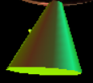I changed the base of the balloons from a structure of three triangles to a single cone, mainly because of the gratefully suggestion offered by Professor Bailey, which I agreed was the better choice to use visually overall.

Also, the addition of shiny, silver spheres around the scene, which reflects lights from the point light sources surround them was another aspect to my final scene that was not described in my proposal for this project. I decided to add these spheres for a more lively effect to the scene, which I also personally enjoyed including.

There is also the difference of that I was unable to toggle off and on the lighting used or have the option to change the colors of the lights either throughout of the scene, due to some unforeseen complications and inability to fix with the minimal amount of time left to work on the project.

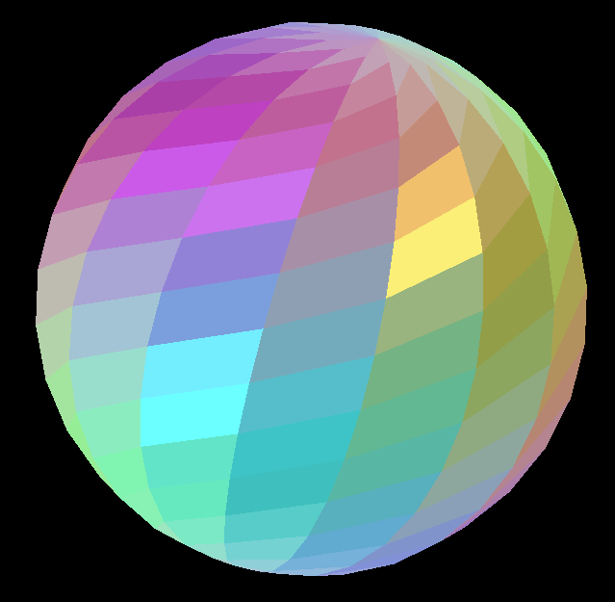**IMPRESSIVE CLEVERNESS**

Mainly occurring on accident, with only applied three different colored light sources within the scene, I was able to create many more colors shown reflecting off of the disco ball in the middle! Which also created a beautiful multi-colored pattern on the balloons, seen when the textures are not applied to them. A variety of a purple, yellow, and blue were the three different colors I used, which through a variety of combinations would produce a large range of colors overall.

**WHAT I LEARNED**

I was able to take the time and learn more about how objects really move around a scene by using the rotate function on my balloons to begin with. Initially, I didn’t realize that depending on where the objects are originally placed within a scene, depends on how they will move when a transformation is applied to them. For example, when you want a certain object to rotate in place, that line of code may not make another object rotate in place if it is in a different location within the scene. So further understanding how objects move when transformations with animations are applied to it is a concept I further developed.

Also, I learned more on how enabling and disabling lighting options is not all that simply as it may be, well, at least based more on how the style of code I had was written. Trying to figure out how lighting is applied and how to disable it, required a deeper understanding than I initially thought it would needed.